|  |
| --- |
| Experiment No. 5 |
| Exploring Files and directories: Python program to append data to existing file and then display the entire file |
| Date of Performance: 14/02/2024 |
| Date of Submission: 21/02/2024 |

**Experiment No. 5**

**Title:** Exploring Files and directories: Python program to append data to existing file and then display the entire file

**Aim:** To Exploring Files and directories: Python program to append data to existing file and then display the entire file

**Objective:** To Exploring Files and directories

**Theory:**

Directory also sometimes known as a folder are unit organizational structure in computer’s file system for storing and locating files or more folders. Python now supports a number of APIs to list the directory contents. For instance, we can use the Path.iterdir, os.scandir, os.walk, Path.rglob, or os.listdir functions.

Python too supports file handling and allows users to handle files i.e., to read and write files, along with many other file handling options, to operate on files. The concept of file handling has stretched over various other languages, but the implementation is either complicated or lengthy, but alike other concepts of Python, this concept here is also easy and short. Python treats file differently as text or binary and this is important. Each line of code includes a sequence of characters and they form text file. Each line of a file is terminated with a special character, called the EOL or End of Line characters like comma {,} or newline character. It ends the current line and tells the interpreter a new one has begun. Let’s start with Reading and Writing files.

**Working of open() function**

We use open () function in Python to open a file in read or write mode. As explained above, open ( ) will return a file object. To return a file object we use open() function along with two arguments, that accepts file name and the mode, whether to read or write. So, the syntax being: open(filename, mode). There are three kinds of mode, that Python provides and how files can be opened:

“ r “, for reading.

“ w “, for writing.

“ a “, for appending.

“ r+ “, for both reading and writing

**Code:**

# Write function

f = open('yash.txt', 'w')

str = input("Enter text : ")

f.write(str)

f.close()

# Append Function

f = open('yash.txt', 'a')

str = input("Enter text : ")

f.write(str)

f.close()

# Read Function

f = open('yash.txt', 'r')

str1 = f.read()

print("The text in the file is : ", str1)

f.close()

# Accessign string from a specific position

f = open('yash.txt', 'r')

f.seek(4)

print("The seeked string from 4th byte is ", f.read())

f.close()

#ReadLine

f = open('yash.txt', 'r')

print("The first line is : ", f.readline())

f.close()

**Output:**

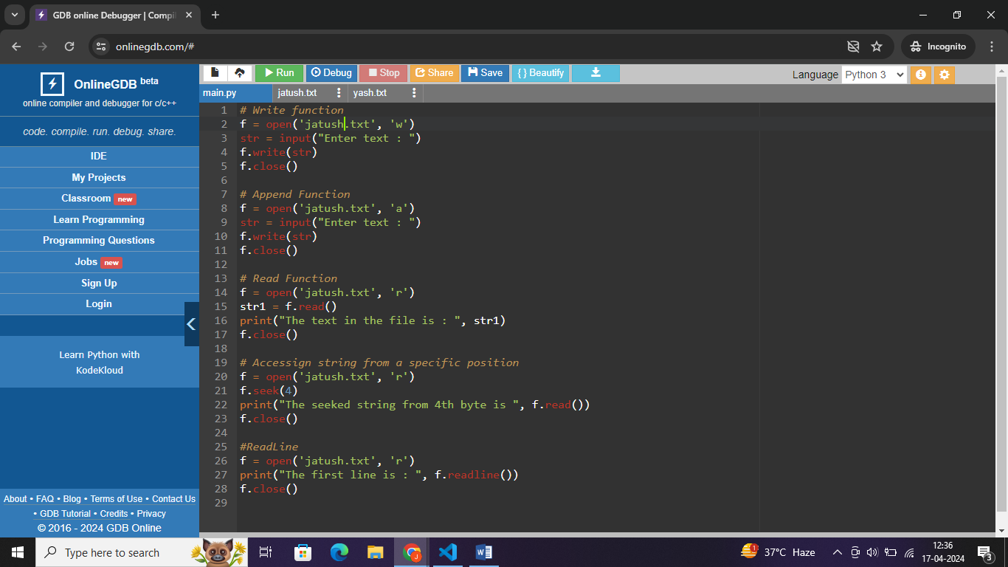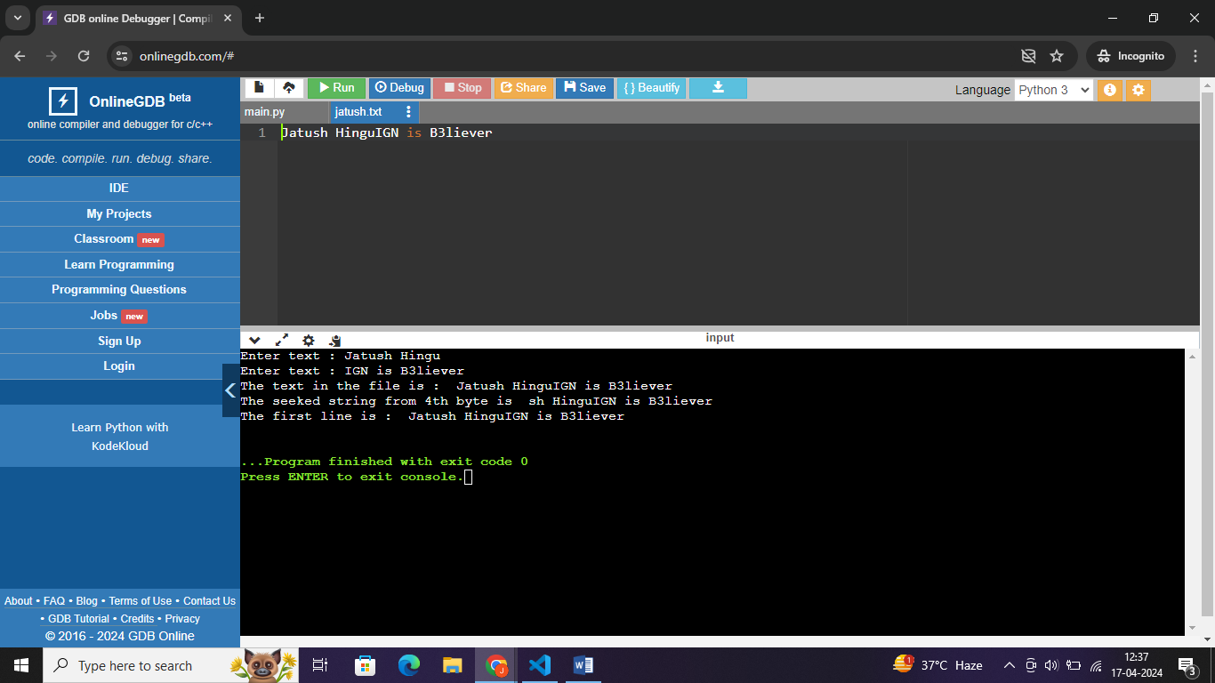

**Conclusion:**

The program demonstrates file handling operations in Python, including writing, appending, reading, seeking, and reading lines from a file. It allows users to input text and interact with files dynamically, showcasing flexibility in file manipulation. By opening, writing to, and reading from a text file named "yash.txt," the script explores various file-related functionalities. This comprehensive exploration enhances understanding of file handling mechanisms in Python, facilitating efficient data management and manipulation tasks.